Lumiere Beauty Media Paid Performance Analysis
Campaign Period: October – November
Prepared By: Garima Kochale
Tools Used: Microsoft Excel & Powerpoint

Executive Summary
This project presents a Paid Media Campaign Performance Dashboard developed using Microsoft Excel. The objective of this dashboard is to evaluate the effectiveness of digital marketing campaigns across multiple channels including Meta Ads, Google Search, YouTube, and Influencer marketing.
The dashboard provides insights into key performance indicators such as Total Spend, Revenue, Conversions, and ROAS. It enables comparison of different strategies, placements, and channels to identify high-performing areas and optimize marketing spend.
The following key business questions were analyzed:
- Which marketing channel delivers the highest return on investment?
- How effective is retargeting compared to prospecting?
- Which placements and formats perform best?
- What is the contribution of brand vs generic keywords?
- Which influencers drive maximum revenue?
- How does performance vary across campaign periods?
The dashboard uses pivot tables, charts, and slicers to provide an interactive and insight-driven analysis.

Data Understanding
The dataset used in this project consists of campaign-level data collected from multiple digital marketing platforms.
The data includes:
- Meta Ads performance (strategy & placement)
- Google Search keyword performance
- YouTube campaign data
- Influencer marketing data
- Sales performance data
These datasets are structured to allow analysis across different dimensions such as channel, strategy, placement, and time.

Data Preparation
Before building the dashboard, the data was cleaned and standardized in Excel.
The following steps were performed:
- Removed null values and inconsistencies
- Standardized naming (e.g., city names, campaign labels)
- Handled missing values (\N replaced with blanks)
- Created helper columns (Total Cost, ROAS)
- Ensured proper data types (numeric, text, date)
These steps ensured the dataset was accurate and ready for analysis.

Data Modeling & Calculation
Pivot Tables were used to summarize and analyze data across different dimensions.
Key calculations included:
- Total Spend = Sum of spend across channels
- Total Revenue = Sales data aggregation
- ROAS = Revenue / Spend
- Total Cost (Influencer) = Flat Fee + Commission
Helper columns were created outside pivot tables to ensure accurate calculations.
Dashboard
An interactive dashboard was built using Excel charts and slicers.
The dashboard includes:
- KPI Cards (Spend, Revenue, ROAS, Orders)
- Strategy Analysis (Retargeting vs Prospecting)
- Placement Analysis (Feed, Reels, Stories)
- Google Keyword Performance
- YouTube Format Performance
- Influencer Contribution Analysis
- Monthly Trend Analysis
Slicers were added for dynamic filtering by Month, Strategy, and Device.
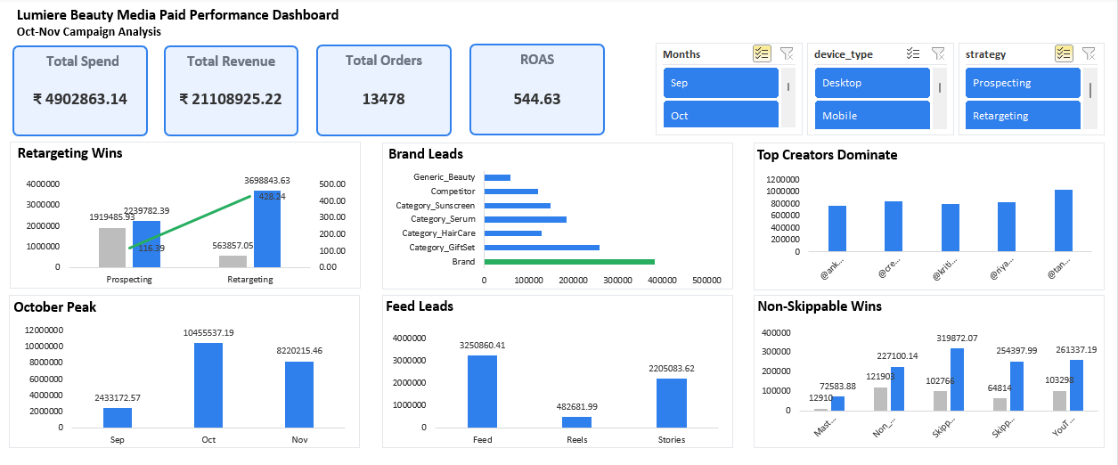

Key Insights
- Retargeting campaigns delivered significantly higher ROAS compared to prospecting
- Brand keywords contributed the highest share of revenue
- Feed placement and mobile devices drove maximum conversions
- A small group of influencers generated majority of the revenue
- Campaign performance peaked during October

Recommendations
Do Differently
- Reduce spend on low-performing placements
- Optimize non-performing keyword categories
- Improve targeting for prospecting campaigns
Keep the Same
- Continue focus on retargeting campaigns
- Maintain strong brand keyword strategy
- Scale high-performing influencers

Conclusion
This project demonstrates how Excel can be used to build an interactive marketing dashboard for campaign performance analysis.
The dashboard enables clear visibility into performance metrics, helping in identifying growth opportunities and optimizing marketing strategies.
It supports data-driven decision-making by highlighting high-performing channels and areas requiring improvement.

